WEEK 2
CREATE TABLE
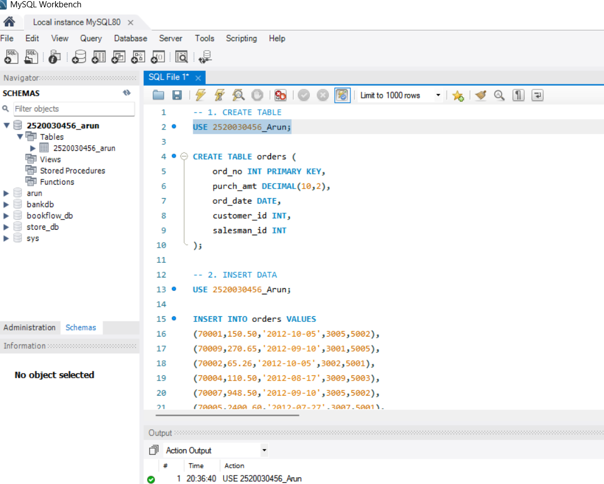
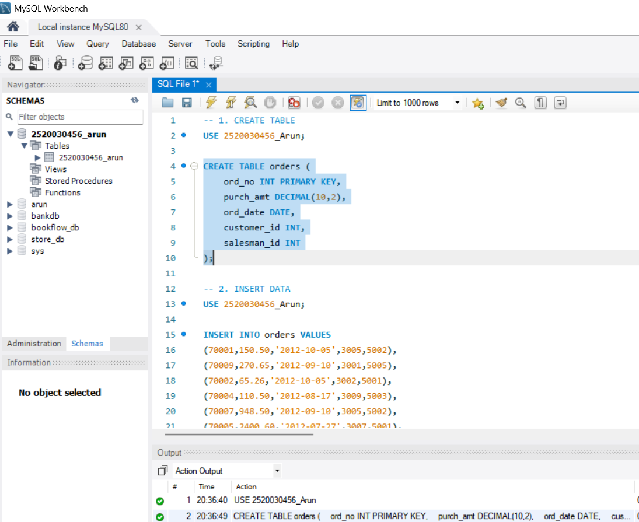

INSERT DATA
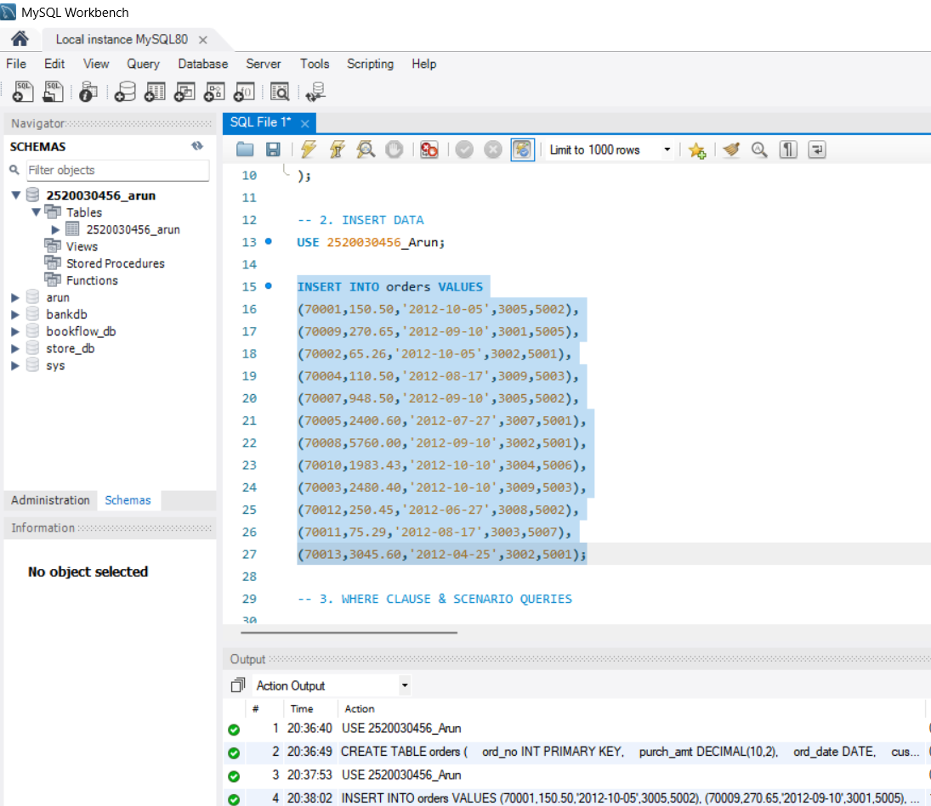
SCENARIO:
Finance wants all orders whose purchase amount is greater
than $2,000.

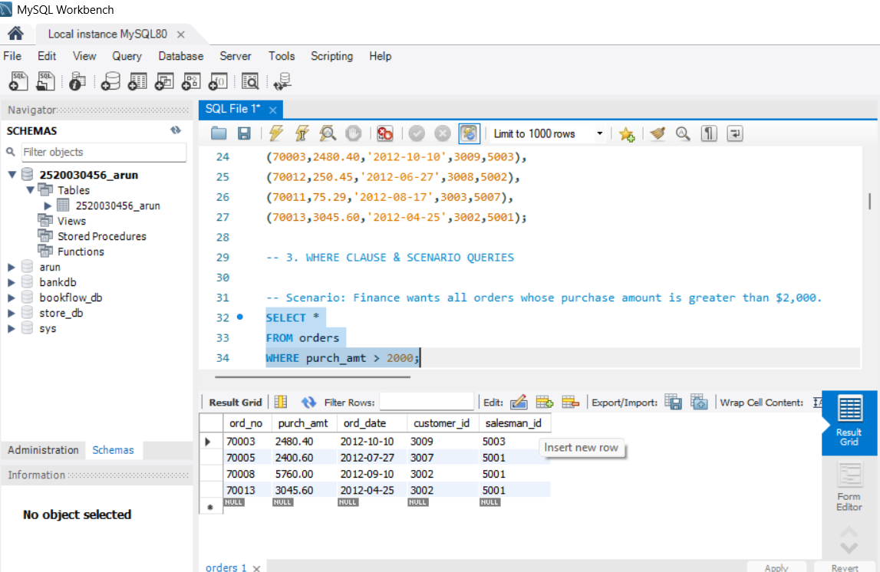
SCENARIO:
Management wants all orders placed on 2012-09-10.

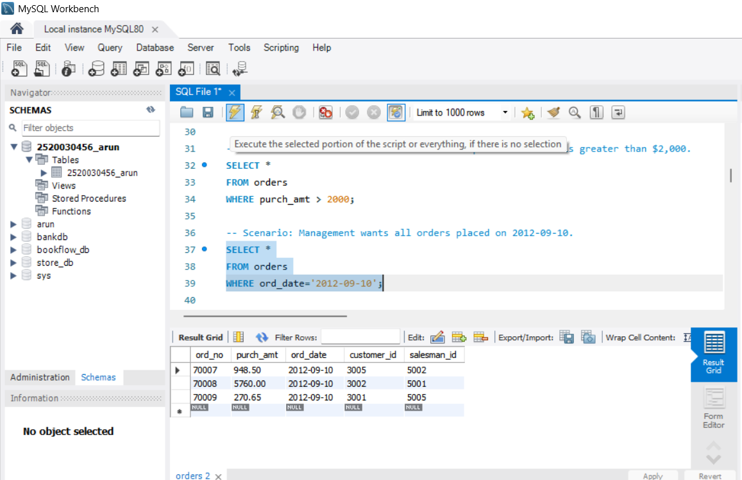

SCENARIO:
Find all orders handled by salesman 5001.
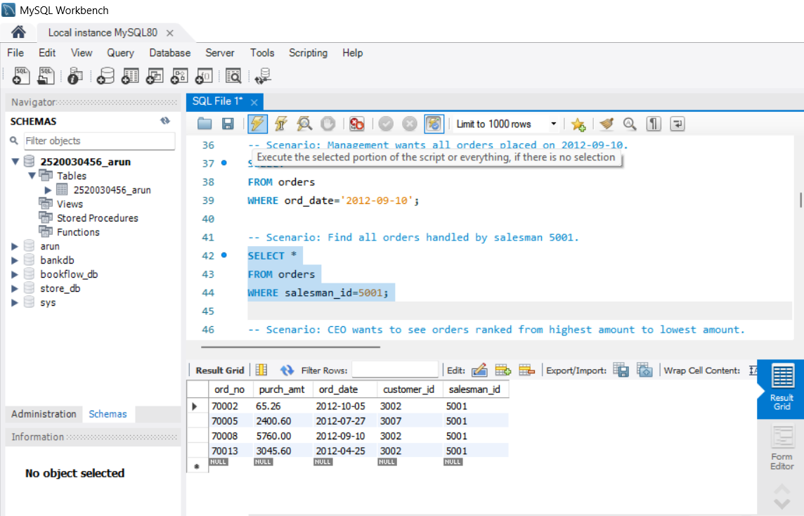
SCENARIO:
CEO wants to see orders ranked from highest amount to
lowest amount.
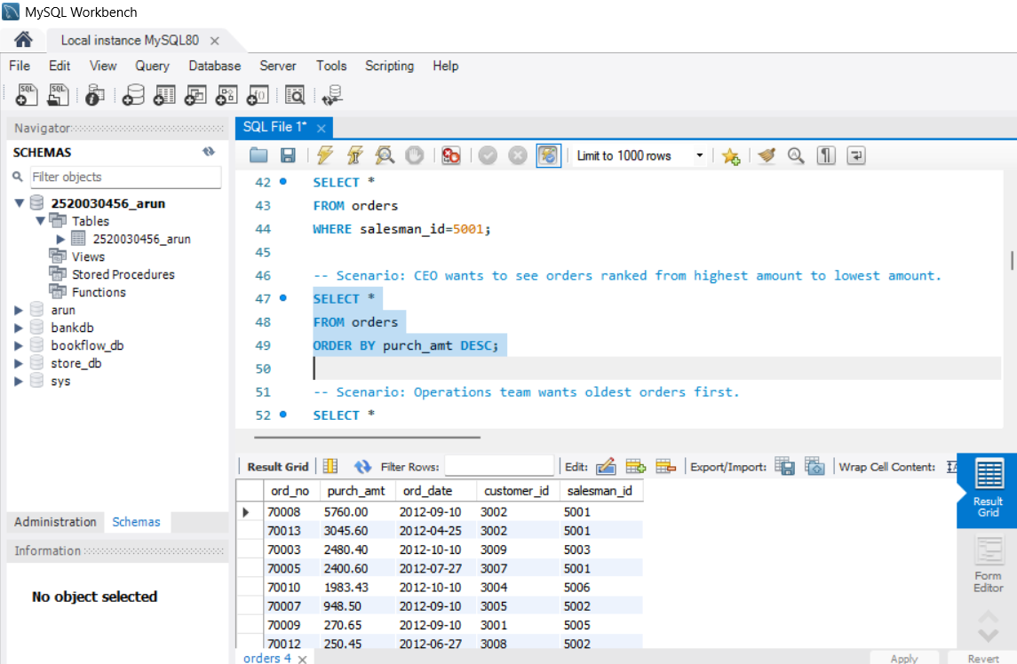

SCENARIO:
Operations team wants oldest orders first.
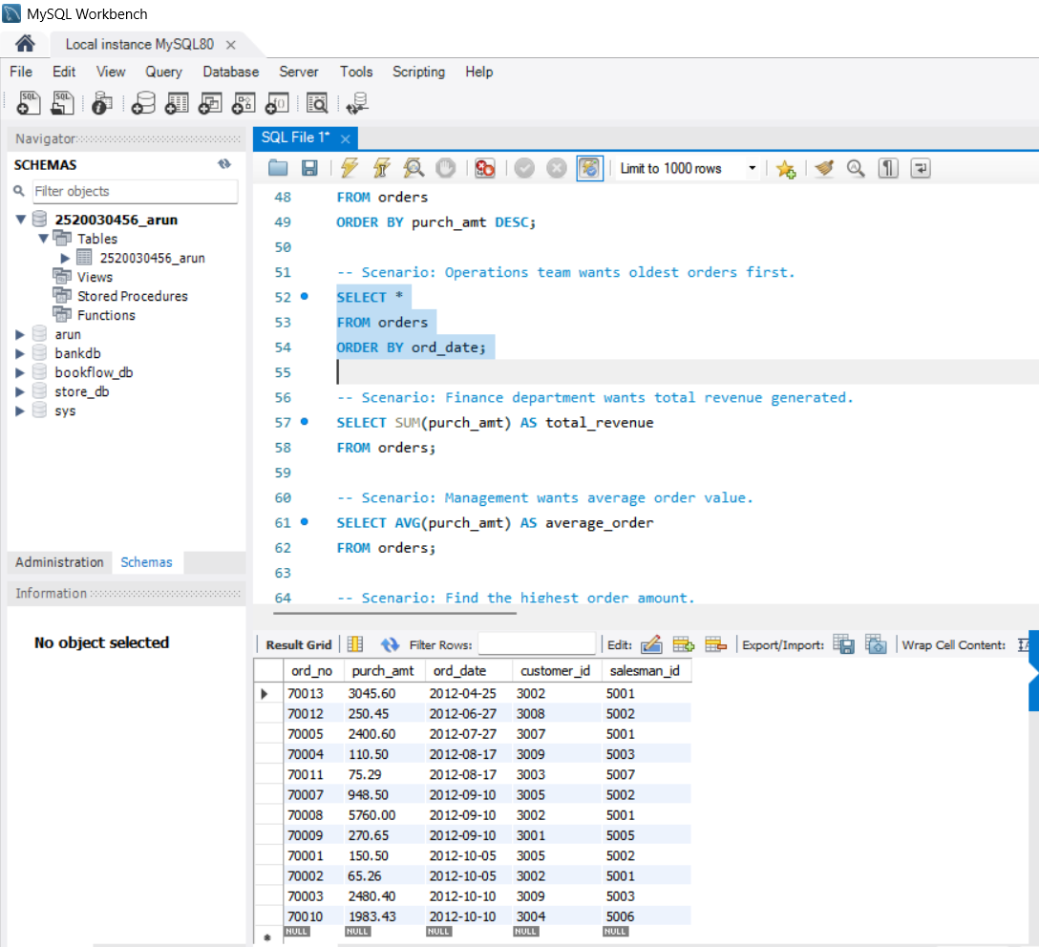

SCENARIO:
Finance department wants total revenue generated.
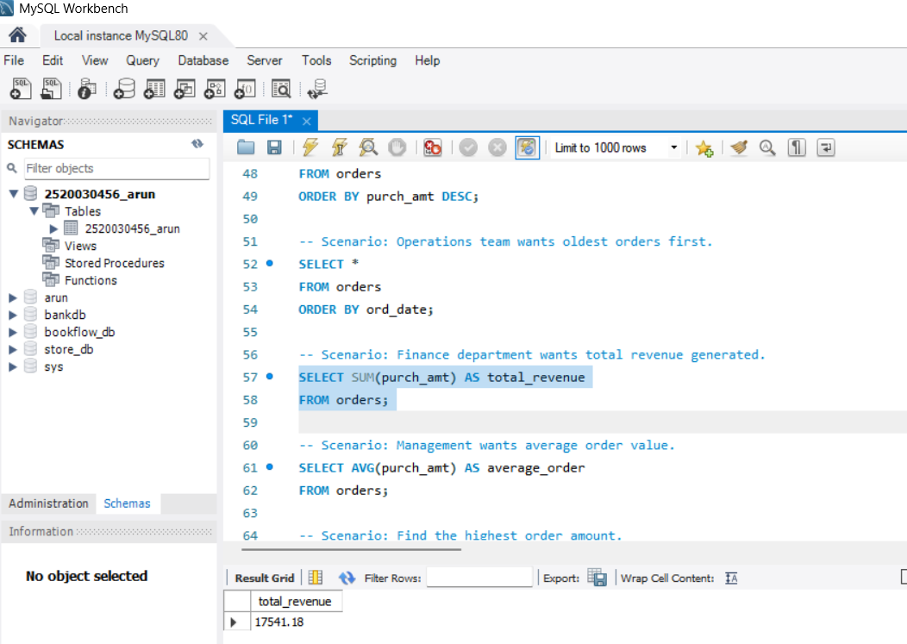

SCENARIO:
Management wants average order value.

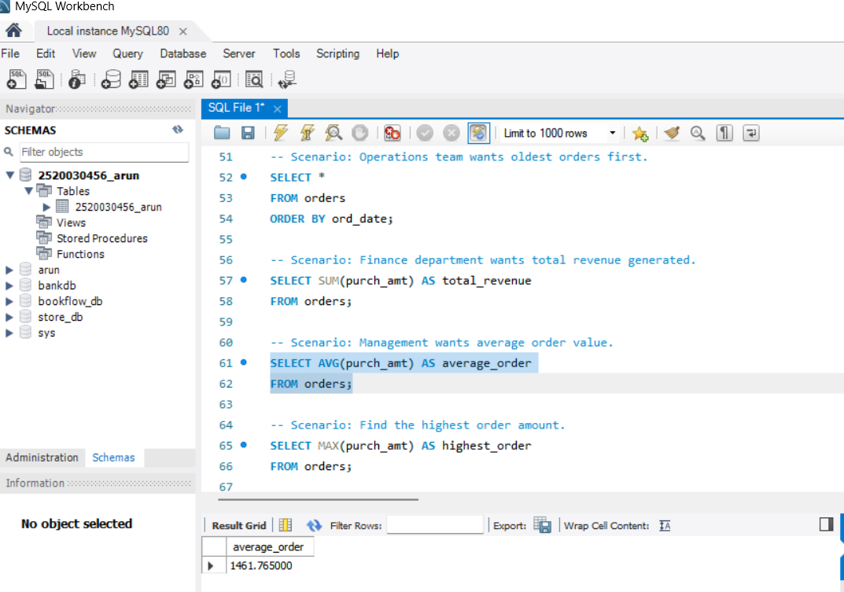
SCENARIO:
Find the highest order amount.

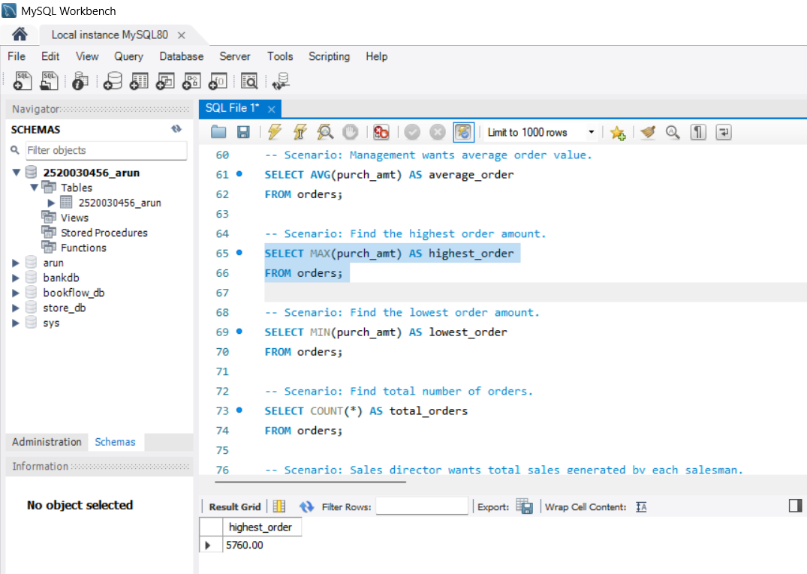
SCENARIO:
Find the lowest order amount.
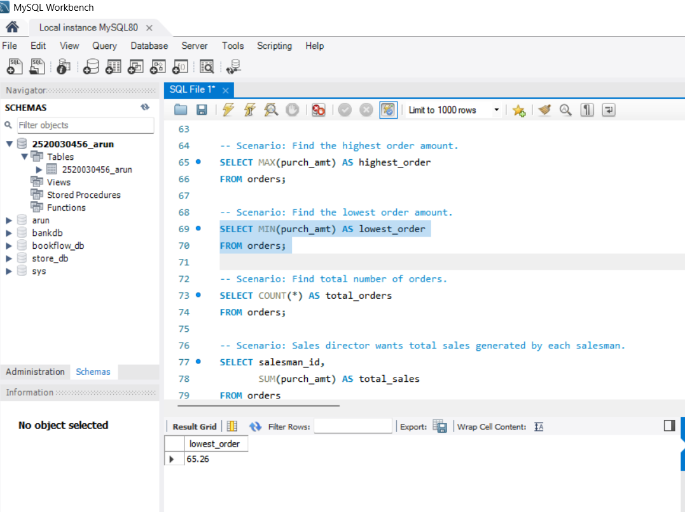
SCENARIO:
Find total number of orders.
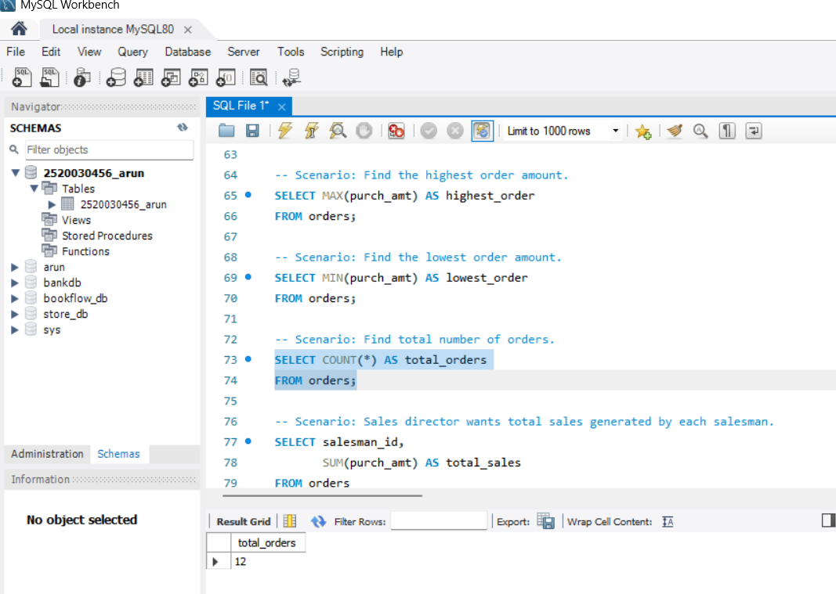
SCENARIO:
Sales director wants total sales generated by each
salesman.

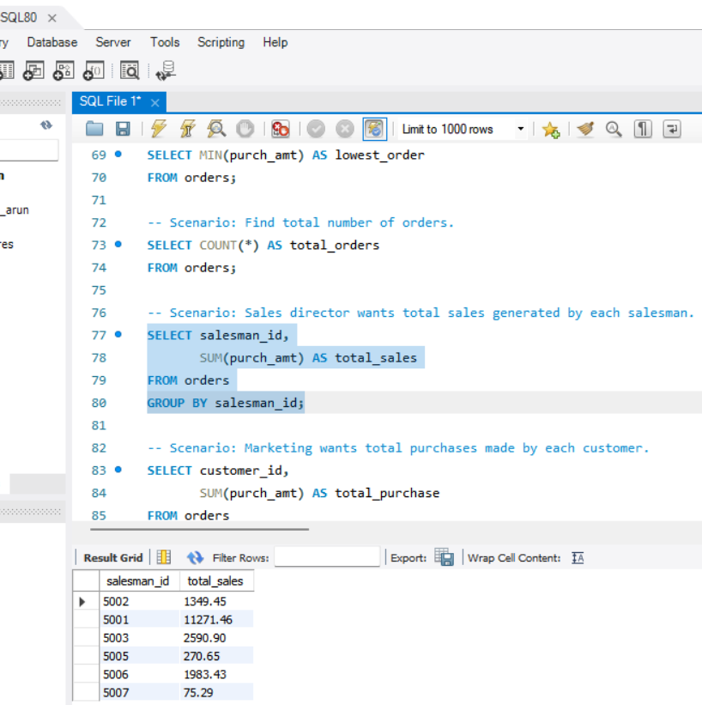
SCENARIO:
Marketing wants total purchases made by each customer.
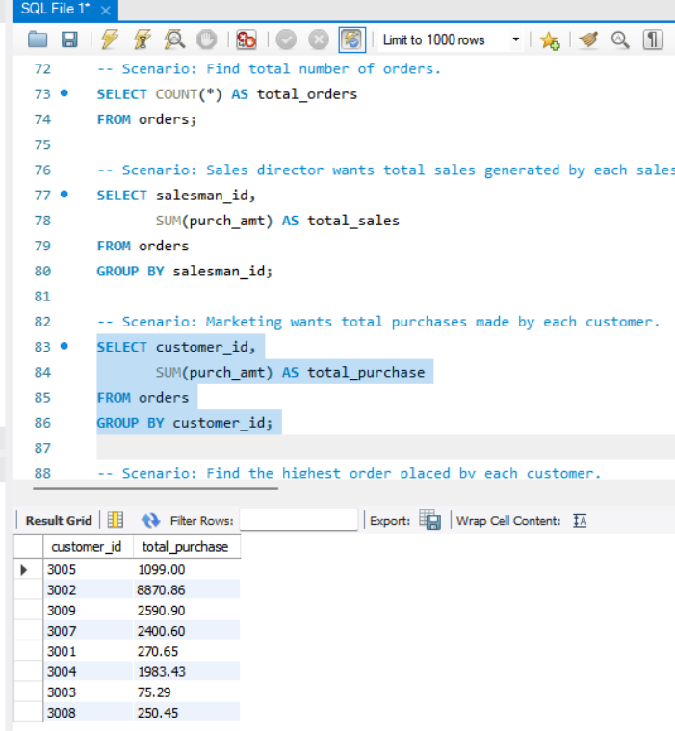
SCENARIO:
Find the highest order placed by each customer.
